Project design phase-I

# Solution Architecture

|  |  |
| --- | --- |
| Date | 14 October 2022 |
| Team ID | PNT2022TMID40695 |
| Project Name | IoT Based Smart Crop Protection System  for Agriculture |

## Sensors

Farmers

cellphone

Power supply 5V

Data

GGGGGGGGGG



Temperature sensor

Humidity sensor

Soil moisture

Water level monitor

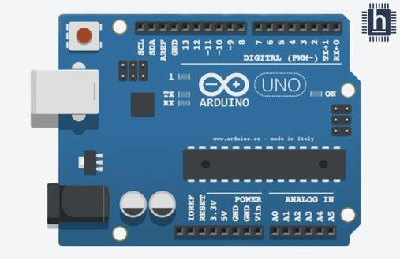

Centralized Arduino

board

sent

Agricultural field

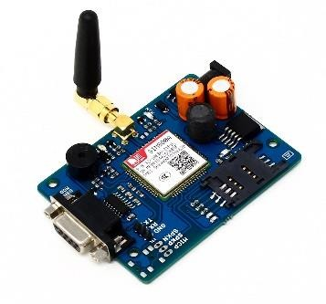

GSMGPRS module

Analog signals

## Data transferred

**IOT cloud services**

## Motor controller

Water pump

IBM Watson IOT Platform

Clarifai service

Relay Driver

Node-RED

**Water flow**

## Output

Alarm

# DESCRIPTION:

* The device will detect the animals and birds using the Clarifai service
* If any animal or bird is detected the image will be captured and stored in the IBM Cloud object storage
* It also generates an alarm and avoid animals from destroying the crop
* It also generates an alarm and avoid animals from destroying the crop
* The image URL will be stored in the IBM Cloudant DB service
* The device will also monitor the soil moisture levels, temperature, and humidity values and send them to the IBM IoT Platform
* The image will be retrieved from Object storage and displayed in the web application.
* A web application is developed to visualize the soil moisture, temperature, and humidity values
* Users can also control the motors through web applications